IKEA CUSTOMER RETENTION ANALYTICS
Retail Customer Retention Analytics – IKEA
1. Project Overview
Objective
The objective of this project is to analyze customer retention behavior at IKEA using transactional, demographic, loyalty, store, and churn data. The goal is to identify churn patterns, understand repeat purchase behavior, evaluate loyalty and promotions, and provide actionable insights to improve customer retention and long-term value.
Business Problem
With increasing competition from online-first furniture brands and local retailers, customer retention has become critical for IKEA. Existing reports are largely descriptive and do not clearly explain:
- Why customers churn
- Which customers are loyal or at risk
- How loyalty programs and promotions impact retention
This dashboard aims to bridge that gap.
Tools Used
- Power BI
- Power Query Editor
- DAX Measures
Datasets Used
- Customer_Demographics
- Customer_Transactions
- Store_Locations
- Loyalty_Program
- Churn_Labelled_Customers

2. Task 1: Data Modeling and Cleaning
Data Cleaning (Power Query)
- Removed duplicate records based on key identifiers within each dataset (such as Customer_ID and Store_ID)
- Converted date columns into proper date formats
- Ensured numeric data types for transaction amount and loyalty points
- Handled missing values using filtering and replacements
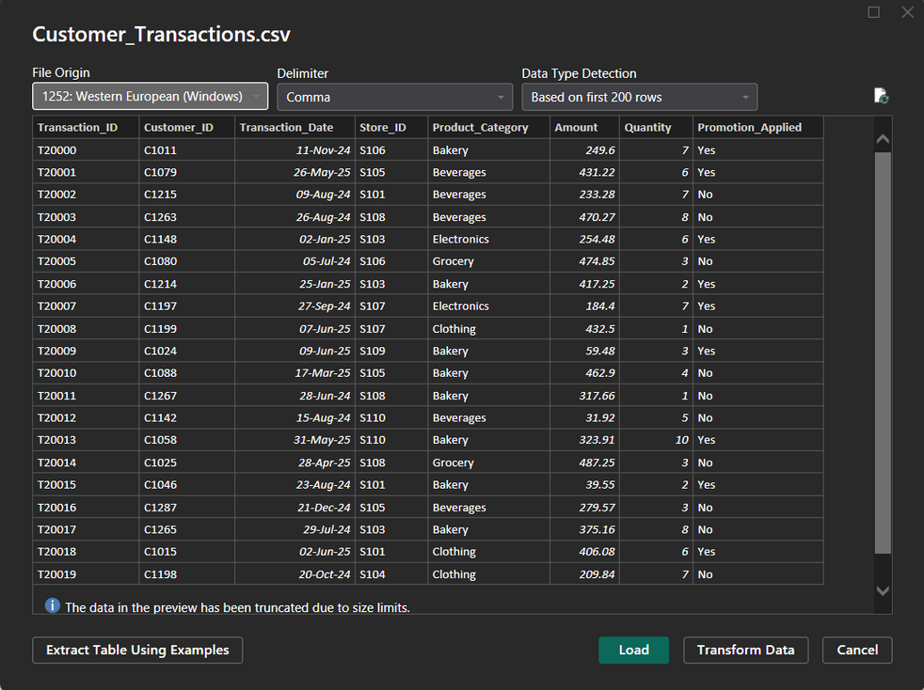
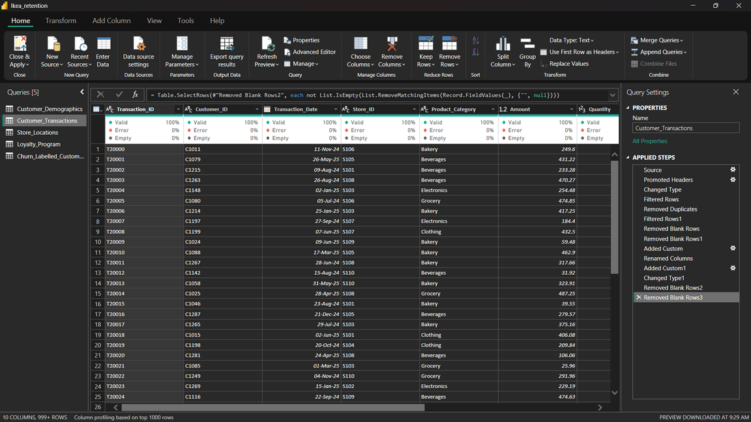
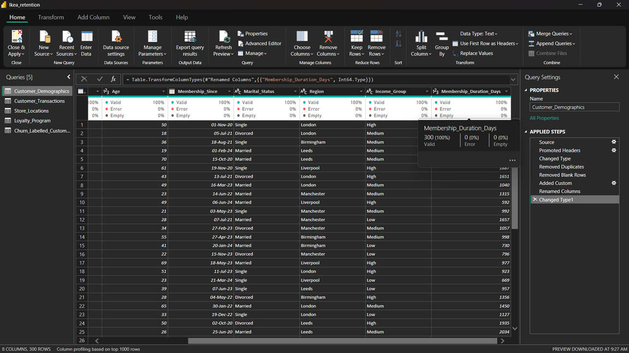
Calculated Columns
- Membership_Duration_Days = Difference between Today’s date and Membership_Since date
- Transaction Year and Transaction Month extracted from Transaction Date
Data Model
- One-to-many relationships were established between Customer_Demographics and Customer_Transactions, Loyalty_Program, and Churn_Labelled_Customers using Customer_ID
- A many-to-one relationship was created between Customer_Transactions and Store_Locations using Store_ID.
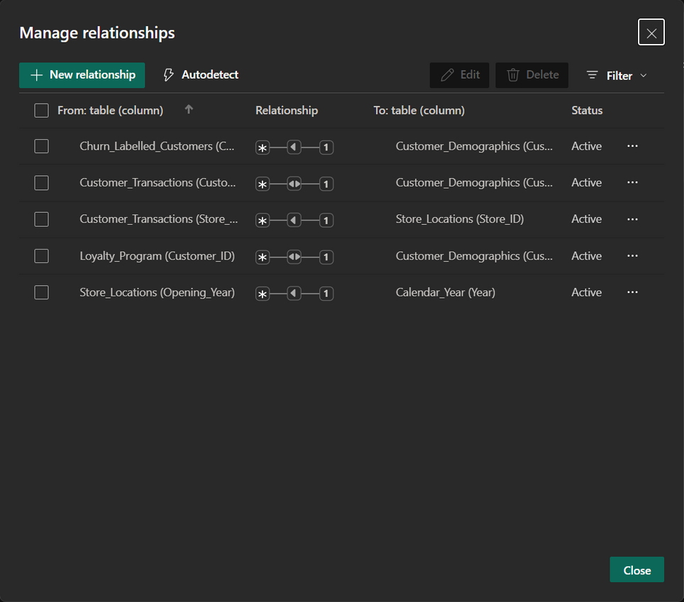
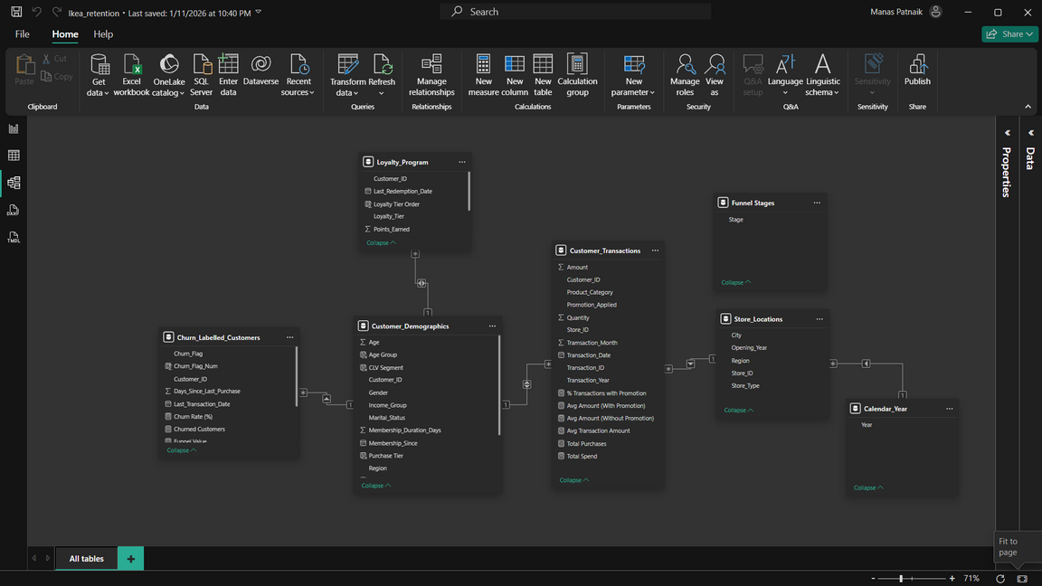

3. Task 2: Churn and Retention Metrics
Churn Rate
Churn Rate was calculated using the formula:
(Churned Customers / Total Customers) × 100
Analysis Performed
- Churn rate by Region
- Churn rate by Income Group
- Churn rate by Store Type
- Top 5 segments with highest churn
A funnel visualization was created to show the flow from total customers to repeat and churned customers.
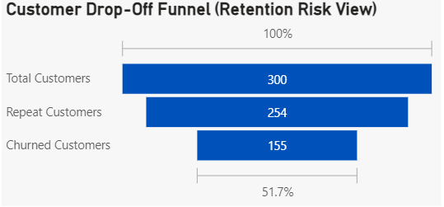
This funnel helps identify critical customer drop-off points where retention interventions can be most effective.
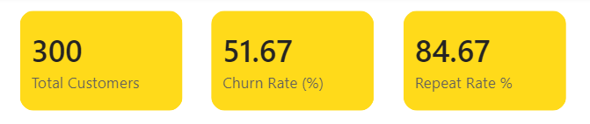
Key retention KPIs summarizing total customers, overall churn rate, and repeat purchase rate.
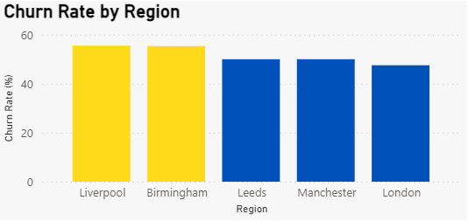
Regional churn rate comparison highlighting Liverpool and Birmingham as the highest churn regions.
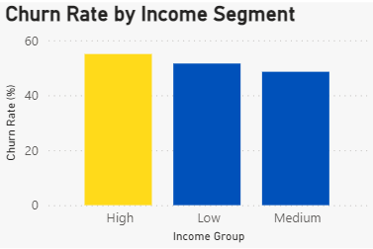
Churn rate by income group showing higher churn among high-income customers compared to other segments.
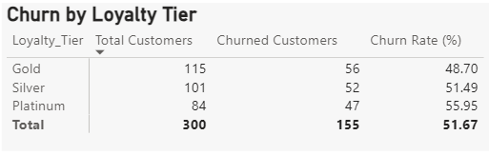
Churn analysis by loyalty tier indicating higher churn among Platinum customers despite loyalty benefits.
The churn analysis reveals a high overall churn rate of 51.67%, indicating that repeat purchases alone do not guarantee long-term retention. Regional analysis highlights Liverpool and Birmingham as high-risk regions, while income-based segmentation shows higher churn among high-income customers. Loyalty tier analysis further indicates that Platinum members exhibit the highest churn despite receiving additional benefits. These insights suggest the need for targeted, value-driven retention strategies rather than generic loyalty incentives.
4. Task 3: Repeat Purchase Analysis
Customer Segmentation
Customers were segmented based on purchase frequency:
- Low Tier: 2–4 purchases
- Mid Tier: 5–10 purchases
- High Tier: 11+ purchases
Analysis
- Average purchase frequency compared by Region
- Average purchase frequency by Age Group
- Comparison across Loyalty Tiers
Additionally, product categories frequently purchased by loyal customers were identified.
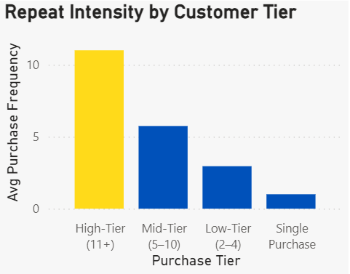
Customer segmentation by purchase frequency shows that high-tier customers demonstrate significantly higher repeat purchase intensity compared to other tiers.
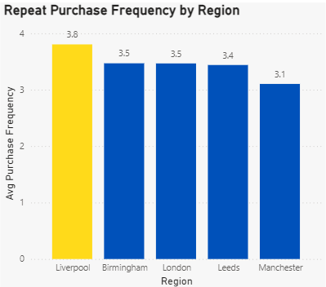
Average purchase frequency by region showing stronger repeat behavior in regions such as Liverpool.
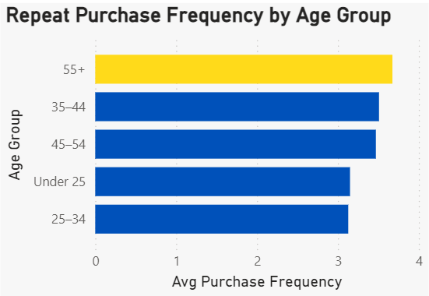
Repeat purchase behavior across age groups, with older age segments showing higher purchase frequency.
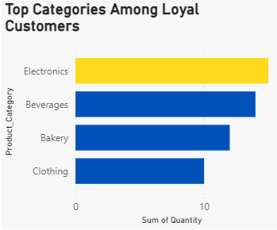
Product categories most frequently purchased by loyal (high-tier) customers.
This indicates that loyal customers tend to concentrate their spending in specific product categories, creating opportunities for targeted cross-selling and personalized recommendations.
Customers were segmented into low, mid, and high tiers based on purchase frequency to analyze repeat behavior and loyalty depth. The analysis shows that while high-tier customers form a smaller portion of the customer base, they demonstrate significantly higher purchase intensity and contribute disproportionately to repeat transactions.
Regional analysis indicates variation in repeat behavior, with certain regions exhibiting stronger customer loyalty. Age-based segmentation shows that older customer groups tend to have higher purchase frequency, suggesting more stable buying behavior.
Further analysis of product categories reveals that loyal customers consistently purchase from specific categories such as Electronics, Beverages, and Bakery. These insights highlight opportunities for targeted cross-selling, personalized recommendations, and loyalty-driven engagement strategies to increase repeat purchases.

5. Task 4: Promotion & Loyalty Impact
Promotion Analysis
- Percentage of transactions with promotions applied
- Comparison of average purchase value with and without promotions
Loyalty Analysis
- Churn rate comparison across loyalty tiers
- Points earned vs points redeemed visualized using a clustered column chart
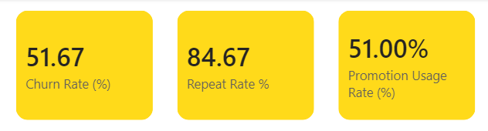
Key promotion and retention KPIs showing churn rate, repeat rate, and overall promotion usage.
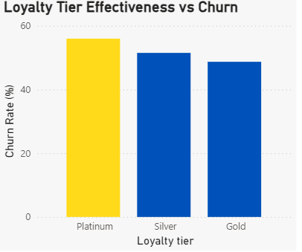
Churn rate comparison across loyalty tiers, indicating higher churn among Platinum customers.
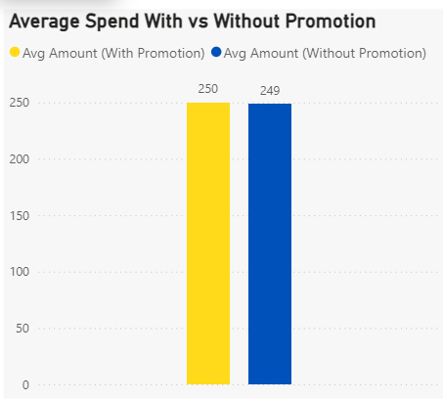
Comparison of average transaction value for purchases made with and without promotional offers.
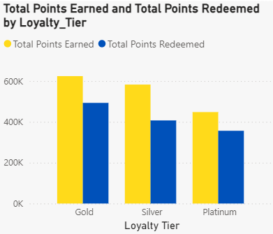
Loyalty points earned versus redeemed across loyalty tiers, highlighting gaps in reward utilization.
Promotion analysis indicates that 51% of transactions involve promotional offers, demonstrating a strong reliance on discounts to drive purchases. A comparison of average transaction values shows that transactions made with promotions have a slightly higher average spend than those without promotions, suggesting that promotions help increase basket value.
Loyalty tier analysis reveals that Platinum customers exhibit the highest churn rate, followed by Silver and Gold tiers. This indicates that higher loyalty status alone does not guarantee customer retention without sustained engagement.
Points analysis highlights a consistent gap between points earned and points redeemed across all loyalty tiers, particularly among higher-tier customers. This suggests that customers may not be fully aware of, or motivated to use, available loyalty rewards.

6. Task 5: Store Performance vs Retention
Store-Level Analysis
- Average transaction amount by store type
- Churn rate by store region
- Relationship between store opening year and retention
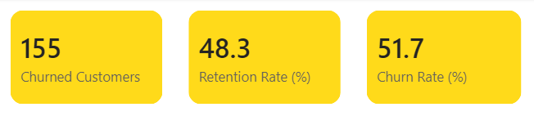
Key store-level retention KPIs showing total churned customers, retention rate, and churn rate.
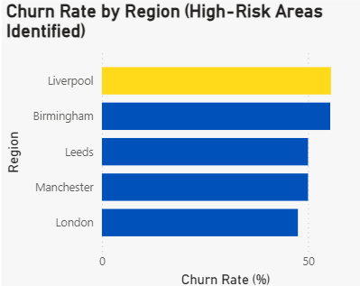
Regional churn rate comparison identifying Liverpool and Birmingham as high-risk regions.
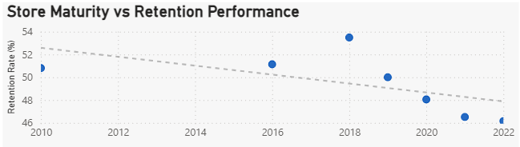
Relationship between store opening year and retention performance, showing declining retention in newer stores.
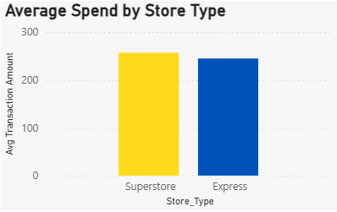
Average transaction amount across store formats, highlighting higher spend in superstores.
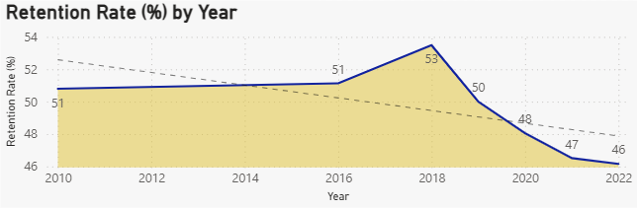
Trend of customer retention rate over time, indicating a decline in recent years.
Store-level analysis was conducted to understand how store characteristics influence customer retention. Regional analysis shows that Liverpool and Birmingham experience the highest churn rates, identifying them as priority areas for retention-focused interventions.
Analysis of store maturity reveals that older, more established stores tend to demonstrate better retention, while newer stores show relatively lower retention performance. This suggests that customer familiarity, operational stability, and localized engagement play an important role in retention outcomes.
Store format analysis indicates that superstores generate higher average transaction values compared to express stores, highlighting their potential role as retention and engagement hubs rather than purely revenue centers.

7. Task 6: Customer Lifetime Value (CLV) Analysis
CLV Calculation
CLV was calculated as:
Total Amount Spent / Membership Duration (in years)
Segmentation
Customers were segmented into:
- Low CLV (Bottom 25%)
- Medium CLV (Middle 50%)
- High CLV (Top 25%)
Visual Analysis
- CLV vs Days Since Last Purchase
- CLV by Loyalty Tier and Region
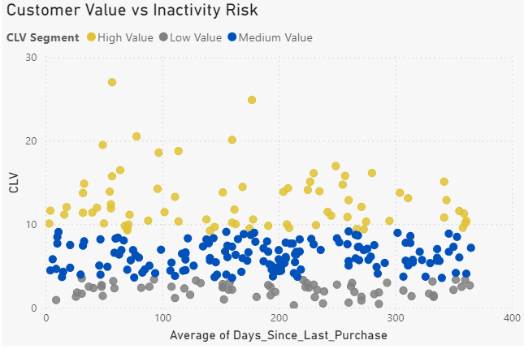
Customer lifetime value comparison across loyalty tiers and regions.
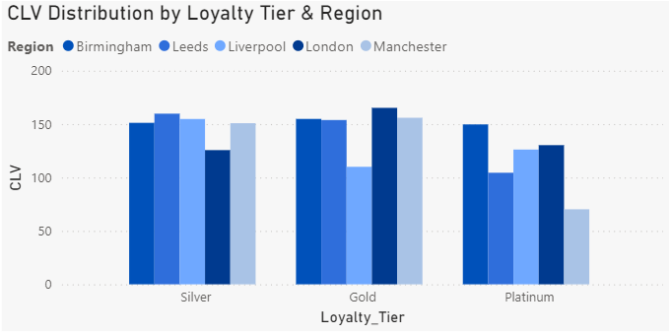
Key insights derived from CLV analysis highlighting value concentration and regional variation.
Customer Lifetime Value (CLV) was calculated to identify and prioritize high-value customers based on their total spending relative to membership duration. Customers were segmented into low, medium, and high CLV groups using quartile-based segmentation.
The CLV versus inactivity analysis shows that while a small proportion of customers contribute a disproportionately high share of total CLV, some high-value customers exhibit extended periods of inactivity. This indicates silent churn risk, where valuable customers may disengage without immediate churn signals.
Further analysis reveals that CLV varies across regions and loyalty tiers, with Gold and Platinum customers contributing significantly higher value across multiple regions. These insights highlight opportunities for targeted retention and reactivation strategies focused on high-value customers rather than broad, discount-driven approaches.
Business Implications
- Prioritize reactivation of high-CLV customers with long inactivity periods
- Shift from blanket promotions to CLV-driven, personalized retention strategies
- Align loyalty benefits and outreach efforts with customer value rather than purchase count alone

8. Task 7: Executive Summary & Recommendations
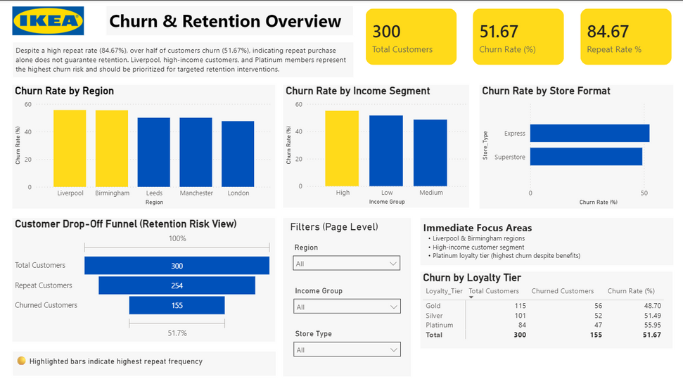
Overall customer retention dashboard summarizing churn, repeat behavior, and high-risk segments.
Key Findings
- Churn is significantly higher among low-tier and non-loyalty customers, indicating weaker long-term engagement in these segments.
- Promotions help increase transaction value but do not consistently prevent customer churn, suggesting limited long-term effectiveness when used alone.
- High-CLV customers are strongly associated with loyalty engagement, yet some exhibit inactivity, representing hidden churn risk.
Top 3 Recommendations
- Strengthen loyalty effectiveness by improving point redemption awareness, simplifying reward usage, and aligning benefits with customer value.
- Target high-churn regions with personalized promotions, localized campaigns, and retention-focused engagement strategies rather than generic discounts.
- Prioritize high-CLV customers through proactive reactivation and personalized communication to maximize long-term customer lifetime value.
Business Impact
Implementing these recommendations can help IKEA reduce customer churn, improve repeat purchase behavior, and maximize long-term revenue by focusing retention efforts on high-value and high-risk customer segments.

9. Video Explanation Link
Drive Link: Google Drive

